Genetic “Degeneracy” Goes the Way of “Junk” DNA
by Dr. Elizabeth Mitchell on September 16, 2014

Surprising evolutionists but not biblical creationists, scientists have discovered an additional layer of information in DNA.

Evolution News and Views: Paper Finds Functional Reasons For "Redundant" Codons, Fulfilling a Prediction from Intelligent Design
With genes, it isn’t just “what they say” but also “how they say it” that counts. The genetic code is the language used by DNA to tell cellular machinery what amino acids to string together into each protein. Those instructions are copied onto messenger RNA (mRNA) and implemented. But in addition to spelling amino acid sequences, the coding regions in DNA, scientists have learned, have embedded in them an additional code!

Two Codes in One
The genetic code “spells” instructions by which ribosomes build proteins using a “three-letter” (three nucleotide) codon to designate each amino acid. (Amino acids are the building blocks of protein.) Some amino acids can be specified by more than one codon. For instance, GGC, GGA, GGU, and GGG are all mRNA codes for the amino acid glycine. Codon “redundancy” is widely considered a “degenerate” evolutionary feature. However, an analysis published in Frontiers in Genetics shows codon redundancy is neither random nor “degenerate” but purposeful. Codon redundancy is actually an information-packed code within a code.
Far from being an evolutionary accident, these not-so-redundant and definitely-not-degenerate “synonymous” codons represent an independent secondary code in DNA. Unlike regulatory non-coding regions of DNA (often mistakenly thought of as “junk,”) this secondary independent code is woven into the coding regions of DNA and affects the speed at which amino acids are stitched together by ribosomes.

Not-So-Synonymous
There are four nucleobases used in DNA. (There are also four in RNA. Uracil (U) and thymine (T) are functionally equivalent nucleobases in RNA and DNA, respectively.) With four nucleobases ( “letters”) available to code for twenty amino acids using three-letter codons, there are 4³ = 64 possible codons, so there is plenty of room for redundancy—and as it turns out plenty of room for life’s Designer to use that redundancy to create a whole extra set of instructions right on top of the first.
Simplistic thinking would suggest that if a codon codes for the same amino acid, then a protein made using that substitute should work just as well. But that is not the case. Though certain codons appear to be simple synonyms coding for the same amino acid, in reality the “choice of word”—the particular codon—used in the gene (and in the mRNA matching it) varies the rate at which the ribosome builds that protein.
As ribosomes build proteins, they pause when they encounter signals formed from these “degenerate” codons, researchers report. These “translational pauses” allow “the necessary time to mechanically perform folding operations” on the protein being synthesized. Proper protein function depends on proper folding, so this extra layer of code is very important.

Pausing to Fold
Most proteins do not work correctly unless they are folded into the correct three-dimensional shape. The elaborate way a protein folds is greatly influenced by the way its amino acids interact with each other. The folding is so complex, however, that it cannot wait until synthesis is complete to be folded. Unlike sheets coming out of your dryer, complex protein chains must be folded even while they are being assembled. Various biochemical “chaperones” help with this. This folding takes a little time, and therein lies the importance of the code that authors David D’Onofrio and David Abel have uncovered and begun to crack.
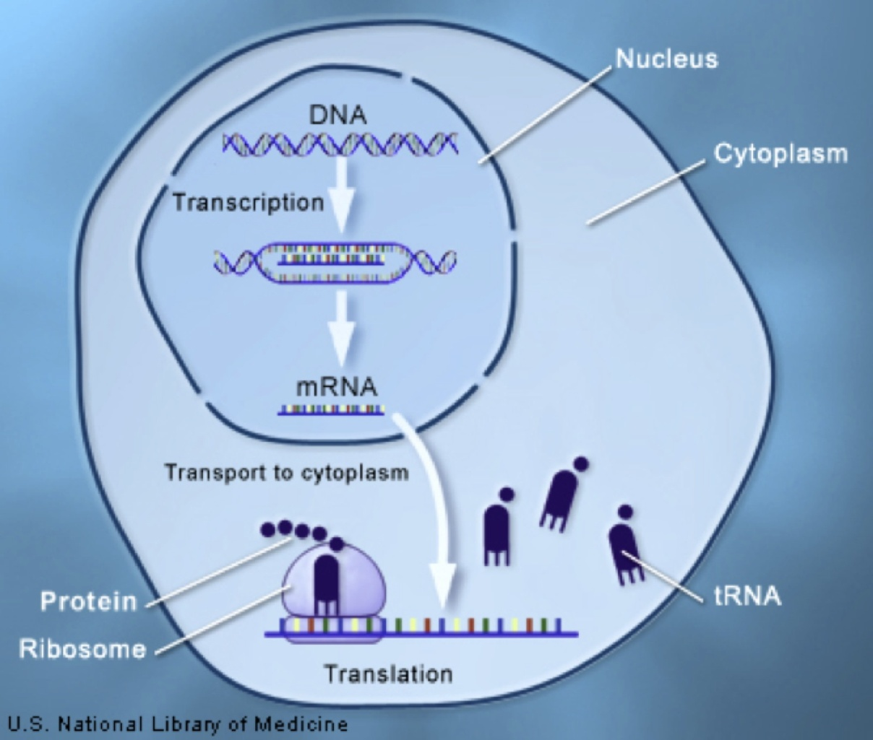
The sequence of nucleotides in a gene is copied (transcribed) into a piece of messenger RNs on the mRNA. Learn more in the discussion guide for Cosmos, episode two, “Some Things Molecules Do.” Image: U.S. National Institutes of Health

Cracking the Code
D’Onofrio and Abel identified a series of “universal pausing rules” in which two “degenerate” three-letter codons appear together as a “hexanucleotide.” Furthermore, each hexanucleotide signal for a translational pause (TP) is consistently and unambiguously interpreted by the ribosome. “The TP codons in the genome constitute a code co-existing with the genetic code,” they write.¹ Furthermore, the “decoding algorithms” are built into the “hardware within the ribosome.”¹
The authors liken the ribosome to a computer processor hard-wired to follow the instructions written in both codes. The ribosome must read both the code for the primary amino acid sequence and the pauses that allow the protein to be properly folded. After all, a code is completely useless without a code-reader! But ribosomes, like the other parts of a cell, are built in accord with the genetic blueprint in a cell. Once again we see the irreducible complexity in the biological systems God designed when He created life.

Design Not Disorder
Evolutionists have long said that the third nucleotide of a codon—the one that often differs in “degenerate” codons—is the “wobble” one, the one that can mutate without causing a problem. Many evolutionary proposals, as detailed by intelligent design proponent Casey Luskin on Evolution News & Views, depend on the assumption that synonymous codons are functionally equivalent. However, nothing about this discovery supports the notion that random natural processes can create information and move it across the biological barriers to increasing complexity as molecules-to-man evolution requires.
Nothing about this precise, unambiguous, critically important secondary code suggests it is a product of random chance. On the contrary, as Answers in Genesis molecular geneticist Dr. Georgia Purdom observes, this study illustrates there is nothing random about the structure of DNA. DNA is a product of design, not disorder!
Multiple codons in DNA, after being transcribed into RNA, code for the same amino acid. For example, GGU, GGC, GGA, and GGG all code for glycine. So it was thought that it didn't matter what codon was used since the same amino acid resulted in the protein. The genetic code was thought to be redundant and the official scientific term is "degenerate." However, nothing could be further from the truth.
Evolutionists have conveniently—and now science confirms quite wrongly—considered non-coding DNA for which they did not know a function to be useless leftover evolutionary “junk.” This discovery now demonstrates that even coding DNA has an additional regulatory code embedded within it.
“Junk” DNA is not junk and the genetic code is not “degenerate!” says Dr. Purdom:
Once again we see an example of codons not being “redundant” and the genetic code not being “degenerate.” Although multiple codons may code for the same amino acid, the codons have other functions too and so the specific codon is important.
This is not the first or even the second time DNA has been found to contain far more information than once thought, says Dr. Purdom. There are multidimensional layers of information that affect not only translation into proteins but transcription itself:
It was discovered late last year that some codons, called duons, not only code for an amino acid but also have regulatory functions that affect transcription—copying genes from DNA into RNA. This dual functionality of codons leaves very little “wiggle room” for evolution and seriously constrains it.
While random mutations might be beneficial for one function of the codon, they would very likely be detrimental to the other function. The genetic code clearly shows design and not disorder.
Concurring with Dr. Purdom, the authors of this study write that they have shown
. . . why the term ‘degeneracy’ is completely inappropriate. This dual coding functionality of redundancy is anything but ‘degenerate.’ It represents, instead, far more sophistication, layers, and dimensions of formal prescription.¹
Discovery Institute’s Casey Luskin notes that intelligent design theory predicts just such information-packed systems in living organisms:
Multidimensional codes and new levels of specified complexity are exactly what ID predicts, and they’re exactly what this paper is reporting. It’s this sort of sophisticated, information-rich control that is expected by intelligent design, in contrast to Darwinian biology which fails to anticipate it. On the contrary, Darwinian advocates publish mountains of papers banking upon the unquestioned assumption that there is no important, functional reason for the existence of “redundant” or “degenerate” features.

The Code-Maker
Indeed, this study illustrates a whole new level of irreducible complexity in the living cell. The genetic code contains the blueprints for building biomolecules of amazing complexity and assembling them into cells and cells into functioning organisms (like us). It is highly sophisticated, containing multiple layers of information in its coding and non-coding regions. Where does the information embodied in the genome, including the information to build the ribosomes to read the coded information, come from? Evolution has no answer.
Without an information-giver, there can be no life. Information is required for life. With no source of information, evolutionary science has never found a way to generate life through random chance from chemical soup. Intelligent design is correct that this wondrous system, like so many others in both biology and physical science, screams “designer!” But just who is that designer?
To identify “the Designer,” the Author of origins, we need a historical record of our otherwise unwitnessed origin. We need an eyewitness account of where we came from. The historical record provided by our Creator in Genesis is constantly confirmed by the observable discoveries in nature. The Author of all the codes embedded in the genetic code—a code system that reaches across all forms of life because it was designed by one Common Designer—is the Creator God of the Bible:
For by Him [Jesus Christ, the Son of God] all things were created that are in heaven and that are on earth, visible and invisible, whether thrones or dominions or principalities or powers. All things were created through Him and for Him. And He is before all things, and in Him all things consist (Col 1:16,17).

For more information:
- Taking out the Trash: Bladderwort DNA Is 97% Junk-free
- Junk DNA and ENCODE Revisited
- Bill, There Is a Book Out There
- Attempts to Trace Life Back to Chemical Origins Maps the Willful Ignorance of the Hunters
- Origins of Life: A Simple Approach?
- Is the Intelligent Design Movement Christian?
- AiG’s Commentary on the ID (Intelligent Design) Movement

https://answersingenesis.org/evidence-for-creation/genetic-degeneracy-goes-way-junk-dna/

Paper Finds Functional Reasons For "Redundant" Codons, Fulfilling a Prediction from Intelligent Design

Casey Luskin August 25, 2014 1:06 PM | Permalink
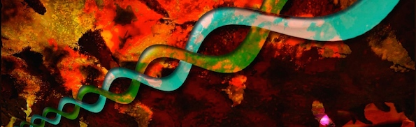
A new peer-reviewed paper in the journal Frontiers in Genetics, "Redundancy of the genetic code enables translational pausing," finds that so-called "redundant" codons may actually serve important functions in the genome. Redundant (also called "degenerate") codons are those triplets of nucleotides that encode the same amino acid. For example, in the genetic code, the codons GGU, GGC, GGA, and GGG all encode the amino acid glycine. While it has been shown (see here) that such redundancy is actually optimized to minimize the impact of mutations resulting in amino acid changes, it is generally assumed that synonymous codons are functionally equivalent. They just encode the same amino acid, and that's it.
Well, think again. The theory of intelligent design predicts that living organisms will be rich in information, and thus it encourages us to seek out new sources of functionally important information in the genome. This new paper fulfills an ID prediction by finding that synonymous codons can lead to different rates of translation that can ultimately impact protein folding and function.
This means that DNA contains multiple languages or encoded commands occupying the same string of contiguous bases. On the one hand, a string of nucleotide bases encodes amino acids. On the other hand, that same string contains information about the rate at which the ribosome should translate the protein so that it can properly fold into the right shape. The paper calls this "translational pausing." The ribosome is capable of reading both sets of commands -- as they put it, "[t]he ribosome can be thought of as an autonomous functional processor of data that it sees at its input." To put it another way, the genetic code is "multidimensional," a code within a code. This multidimensional nature exceeds the complexity of computer codes generated by humans, which lack the kind of redundancy of the genetic code. As the abstract states:
The codon redundancy ("degeneracy") found in protein-coding regions of mRNA also prescribes Translational Pausing (TP). When coupled with the appropriate interpreters, multiple meanings and functions are programmed into the same sequence of configurable switch-settings. This additional layer of Ontological Prescriptive Information (PI_{o}) purposely slows or speeds up the translation decoding process within the ribosome. Variable translation rates help prescribe functional folding of the nascent protein. Redundancy of the codon to amino acid mapping, therefore, is anything but superfluous or degenerate. Redundancy programming allows for simultaneous dual prescriptions of TP and amino acid assignments without cross-talk. This allows both functions to be coincident and realizable. We will demonstrate that the TP schema is a bona fide rule-based code, conforming to logical code-like properties. Second, we will demonstrate that this TP code is programmed into the supposedly degenerate redundancy of the codon table. We will show that algorithmic processes play a dominant role in the realization of this multi-dimensional code.
They write that the ribosome's ability to undergo translational pausing "reveal[s] the ribosome, among other things, to be not only a machine, but an independent computer-mediated manufacturing system." The paper even suggests, "Cause-and-effect physical determinism...cannot account for the programming of sequence-dependent biofunction."
Apart from ID's expectation of finding new layers of information in the genome, the paper implicitly challenges some common evolutionary assumptions. The notion that shared synonymous codons are functionally irrelevant has been used to buttress arguments for Darwinian evolution.
For one thing, some evolutionists claim that phylogenetic signals can be carried by the distribution of synonymous codons since they're functionally equivalent. This paper suggests otherwise.
For another, seeking to infer the activity of natural selection, evolutionary biologists statistically analyze the frequency of synonymous (thought to be functionally unimportant) and nonsynonymous (thought to be functionally important) codons in a gene. (We've discussed this previously here and here.) As the thinking goes, if synonymous codons are functionally unimportant, then three conclusions may follow: a bias toward synonymous codons implies purifying selection in the gene, a bias towards nonsynonymous codons implies positive selection, and an equal balance implies neutral evolution (no selection). But if synonymous codons can have important functional meaning, then the whole methodology goes out the window, and hundreds of studies that used these methods to infer "selection" during the supposed "evolution of genes" could be wrong.
The evidence supports the view that synonymous codons have divergent effects upon translation, as the paper finds: "Data shows that with fixed levels of tRNA's, synonymously encoded mRNA's translate with different speeds" and "Recent work has built on the above observations showing a strong relationship between specific arrangements of codons in mRNA to the rate of translation." Genetic modifications in the lab can even induce translational pausing:
"Pausingfunction" is caused by specific mRNA codon sequences rather than by tunnel-protein interactions to amino acid sequences. This contention is supported by data involving the substitution of rare codons with synonymous codons in E. coli. If the pausing effect was solely related to the amino acid chain sequence, then replacing codons with synonymous codons should still produce the same folded amino acid chain with the same translation speed. However, substitution of rare codons with synonymous codons did produce a change in speed and conformation changes.
These changes in translational speed can have phenotypic effects:
For example, a silent mutation in the human gene ABCB1 caused a conformational change to occur in the P-glycoprotein. This protein folded differently caused by a temporal change in translation affecting the timing of the folding process. ... Thus, the protein folding pathways are affected by changes in the coding regions of DNA" (internal citations removed).
In short, "redundant" codons are not necessarily redundant at all. As the paper puts it: "we show why the term "degeneracy" is completely inappropriate. The dual coding functionality of redundancy is anything but 'degenerate.' It represents, instead, far more sophistication, layers, and dimensions of formal prescription." In fact, this paper "defines new universal linguistic-like rules needed to identify and characterize codon mappings of TP events." The authors write:
The TP code exhibits distinct meaning in relation to mappings between codons and pausing units. The TP code also exhibits a syntax or grammar that obeys strict codon relationships that demonstrate language properties. Because of the redundancy of the genetic code, it could be argued that the TP language is a subset of the genetic language. The subspace of the TP language resides, and thus appears to have a dependency on, the primary genetic code. Within this subspace, however, we argue that the TP language is decoupled from and remains independent of the protein-coding language.
Their conclusion about the high-information capacity of the genetic code is striking:
Redundancy in the primary genetic code allows for additional independent codes. Coupled with the appropriate interpreters and algorithmic processors, multiple dimensions of meaning, and function can be instantiated into the same codon string. We have shown a secondary code superimposed upon the primary codonic prescription of amino acid sequence in proteins. Dual interpretations enable the assembly of the protein's primary structure while enabling additional folding controls via pausing of the translation process. TP provides for temporal control of the translation process allowing the nascent protein to fold appropriately as per its defined function. This duality in the coding function acts to reduce the redundancy in the genetic code when viewed holistically. The functionality of condonic redundancy denies the ill-advised label of "degeneracy." When simultaneously combined with other coding schemas such as intron/exon boundary conditions, and overlapping and oppositely oriented promoters, multiple dimensions of independent coding by the same codon string has become apparent.
In his 2001 book No Free Lunch, William Dembski explained the primary prediction of intelligent design:
[W]hat about the predictive power of intelligent design? Intelligent design offers one obvious prediction, namely, that nature should be chock-full of specified complexity and therefore should contain numerous pointers to design ... This prediction is increasingly being confirmed. (p. 362)
Multidimensional codes and new levels of specified complexity are exactly what ID predicts, and they're exactly what this paper is reporting. It's this sort of sophisticated, information-rich control that is expected by intelligent design, in contrast to Darwinian biology which fails to anticipate it. On the contrary, Darwinian advocates publish mountains of papers banking upon the unquestioned assumption that there is no important, functional reason for the existence of "redundant" or "degenerate" features. Slowly but surely, the data are turning the tide in the evolution debate.

Degeneracy Discarded But Design Discovered
by Dr. Elizabeth Mitchell on November 28, 2014

I am a Biblical Creationist who happens to teach General College Biology at a local community college. My lectures have always included the standard secular treatment regarding the "redundancy" of the genetic code.
Thank you for your September 16 article “Genetic ‘Degeneracy’ Goes the Way of ‘Junk’ DNA” as I am planning on incorporating the original article you cite [David D’Onofrio and David Abel, “Redundancy of the genetic code enables translational pausing,” Frontiers in Genetics (20 May 2014), doi: http://journal.frontiersin.org/Journal/10.3389/fgene.2014.00140/full] into my lectures.
While this is the first time that I have heard of the proposed function for redundancy in the genetic code, others suggest it is old news. Such a suggestion is the topic of the following link:
http://sandwalk.blogspot.com/2014/08/another-stupid-prediction-by.html
I can usually come up with my own response to scathing attacks on Creationist interpretations but I am having a problem in this case. I need help on this one.
Yours in Christ,
T. Z., Colorado, US
Thanks for reading our News to Know columns and for putting the information to use by teaching a broad range of students how to think critically about what they hear. It is always a challenge in articles like these to supply the public with the background research—what’s already known—while communicating what’s new.
For those readers who may not recall the article “TZ” is asking about, “Genetic ‘Degeneracy’ Goes the Way of ‘Junk’ DNA” reports that in addition to dictating amino acid sequences using a series of codons, the protein-coding regions in DNA have embedded in them an additional code! The essence of this code depends on the fact that there are multiple ways to “spell” the “word” (codon) that codes for certain amino acids. In the latest study the authors explain how the second code works and the evidence for their conclusions.
The apparent redundancy of the genetic code, having several codons for the same amino acid, has long been called codon “degeneracy”—evidence that the present genetic code is an evolutionary product.
If “synonymous” codons (meaning they code for the same amino acid) are not redundant, degenerate, and functionally equivalent, but instead have purposeful redundancy in order to provide the building blocks for another code, then the notion that the genetic code is a product of random evolution becomes even more untenable. And if the structure, mechanism, and essential purpose of the secondary code are discovered—as this study suggests—then the observations of science support the fact that life was created by our intelligent Creator. And it is the latter that the study uncovered—not just the way the second code works but also what kinds of instructions it is giving and their vital purpose.
By analyzing data collected by many scientists over time, the authors of the latest study have unraveled the nature and purpose of a previously suspected secondary genetic code superimposed on the primary one. Nothing about this precise, unambiguous, critically important secondary code suggests it is a product of random chance. On the contrary, this study illustrates nothing random about the structure of DNA. DNA is a product of design, not disorder!
As I’m sure you noticed, the article I cited by D’Onofrio and Abel in Frontiers in Genetics is a “review article.” Such reviews of the published literature put together pieces of information reported or suspected by many scientists over a period of time—even decades—sometimes inferring new information and insights from a fresh perspective. Reviews like this are very valuable as they help scientists and the public see the “big picture.” Obviously, the editors of the peer-reviewed journal Frontiers in Genetics thought that “big picture”—in this case a better understanding of a genetic code within a code and the idea that what is still commonly called “degeneracy" is not—was worth publishing. (Perhaps the journal editors failed to consult the Sandwalk blogger who saw nothing new in the study and authored the derisive “Another stupid ‘prediction’ by Intelligent Design Creationists.”)
Additionally, some reviews—like this one—uncover patterns that reveal new information or confirmation of ideas previously only suspected. Through their analysis of three decades of data, D’Onofrio and Abel garner support for conclusions about the actual purpose and function of the superimposed genetic code within a code. Even if some people previously pondered the possibility proposed in the study, explains Answers in Genesis molecular geneticist Dr. Georgia Purdom, that is not the same thing as making a scientific case that such a hypothesis is correct:
I would agree that it has been known for some time that codon usage does slow or pause translation, but I don't believe it's been known that there was a reason for that (folding of proteins). Maybe some people guessed that was the reason, but there wasn't actually measurable scientific evidence of it. All the critical Sandwalk blog does is link to past papers that show translational slowing/pausing occurs but not why it occurs.
Despite strong suspicion that a second layer of code was present in DNA, the term degeneracy, with its evolutionary implication, has persisted. This analysis in Frontiers in Genetics makes a good case for just what that code is doing and why. Biblical creationists understand that the Creator God is the intelligent Designer who is the source of not only the information in the genomes of all kinds of living things but the Author of the very language in the genetic code itself.
God is the Common Designer of all living things. Because all living things reside on the same planet, they have many of the same biochemical needs, and draw from the same basic resources. It is only reasonable that God designed all living things to use the same genetic code, or language. In other words, the nucleotide combinations that stand for amino acids or signals in protein building and even in many regulatory genes are quite consistent across the biological world. That our intelligent Creator would construct a second coded language and superimpose it on the first is a delightfully complex design. Elucidation of what kind of instructions that language is issuing and the reason those instructions are important during protein synthesis is a grand discovery that points to the Author of all genetic codes and information.
That DNA contains a complex multi-level code was not a surprise to biblical creationists, just as the discovery in the ENCODE studies that most so-called “junk” DNA is not a useless evolutionary leftover but has function. The Sandwalk blogger’s argument reminds me of the hue and cry that went up when evidence emerged that most “junk” DNA has some function. Some evolutionary bloggers acted like they’d never considered it junk, while others declared that it was still function-less junk. (As an aside, the existence of some DNA for which we cannot determine a modern function is not proof of an evolutionary history. We may not know the function, or it may have been damaged by mutation, or it may have been switched off through various means.) Read more about this issue in “Junk DNA and ENCODE Revisited.”
Furthermore, if all the information about redundant codons has really been known for 30 years, as the Sandwalk blogger insinuates, why is the term degeneracy still in common use? If this is a beautifully designed, highly functional code, there is nothing “degenerate” about it. Could it be that the evolutionary implications of the word are too convenient and precious to relinquish?
Clearly, most discoveries in science come about through years of incremental efforts on the part of many people. And just as clearly, inconvenient scientific facts are sometimes ignored until they are forced to the surface. (I’m thinking of the fact that the appendix was known to have a role in the immune system for many years while it was still treated as a useless evolutionary vestige by scientists, medical and non-medical alike.) Articles like this one pull together scientific discoveries and draw long overdue conclusions about the big picture. And that makes it news! News that the people—inundated with evolutionary claims conveniently bottled in catchy words (like junk and degeneracy) and cute names for our so-called ancestors (like “Lucy” and “Karabo”)—need to know!

For more information:
- Genetic “Degeneracy” Goes the Way of “Junk” DNA
- Junk DNA and ENCODE Revisited
- Intelligent Design
- The Appendix: Useless Vestige or Evolutionary Innovation?
- The Wonderful World of Bacteria in Your Body

David D’Onofrio and David Abel “Redundancy of the genetic code enables translational pausing,” Frontiers in Genetics (20 May 2014), doi: 10.3389/fgene.2014.00140.journal.frontiersin.org/Journal/10.3389/fgene.2014.00140/full
As examples from the literature demonstrating that protein folding is affected by “silent mutations,” the authors cite one case in which replacing the rare codons in E. coli with their more common synonyms—mimicking a “silent mutation”—produced faster protein translation, but the protein produced was 20% less active and had many mis-folded regions. In another case an apparent silent mutation in a human gene caused a conformational (shape) change in a glycoprotein, also associated with a change in the rate of translation and the timing of the folding. From David D’Onofrio and David Abel “Redundancy of the genetic code enables translational pausing,” Frontiers in Genetics (20 May 2014), doi: 10.3389/fgene.2014.00140.journal.frontiersin.org/Journal/10.3389/fgene.2014.00140/full.
Synonymous codons can differ in any of the three positions, but the difference is most often in the third position. Glycine, for instance, is specified by GGG, GGC, GGA, GGT (in DNA), and GGU (in RNA). (U for uracil and T for thymine are functionally equivalent nucleobases in RNA and DNA, respectively.) Alanine is called for by mRNA codons GCU, GCC, GCA, or GCG. But serine is designated in mRNA by AGU, AGC, UCU, UCC, UCA, or UCG.
God designed all living things with their genetic information encoded in DNA (as well as RNA copies of it) using the same genetic “alphabet.” And because living things on Earth have the same basic needs and biochemical requirements, genes for many commonly needed proteins are understandably similar. If it were otherwise, their coexistence and interaction on the Earth would be problematic. Contrary to this understanding and on the basis of atheistic presuppositions, evolutionists teach that a common genetic alphabet could only have come to exist through the natural evolution of all life-forms from a common ancestor, which itself had to bring itself into existence from nonliving elements through natural processes.

